G9

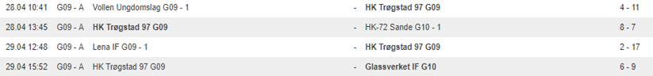

G13

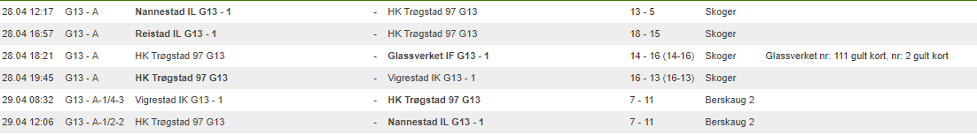

G16

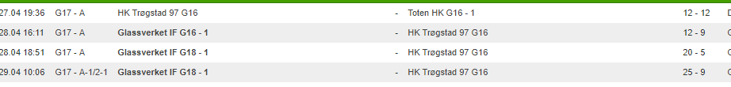

J9

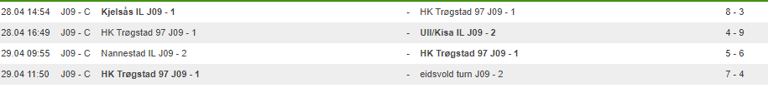

J10

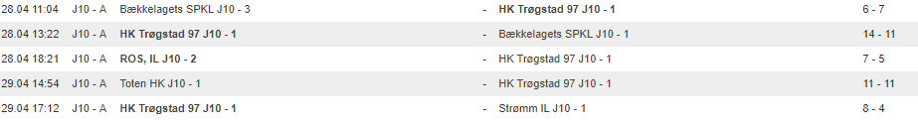

J11

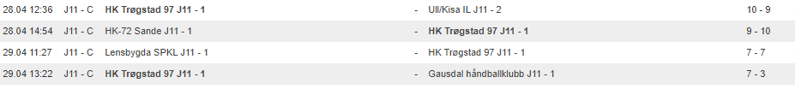

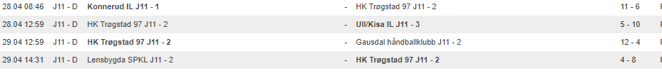

J12

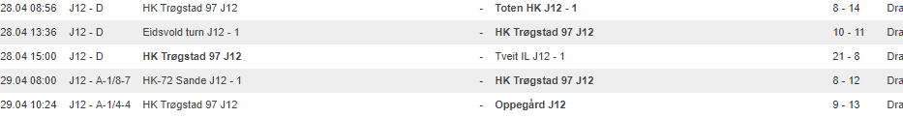

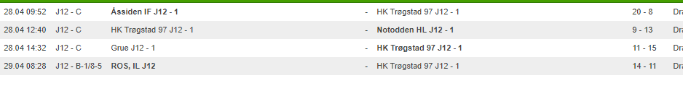

J13

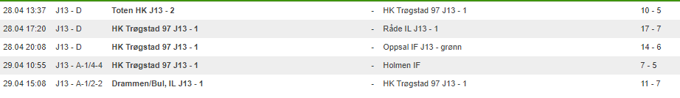

J15

